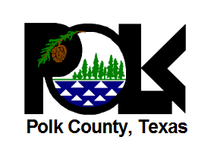

Good news from U.S. Representative Brian Babin -- Polk County received the Presidential Disaster Declaration. Please keep an eye on this page for more details.

Apply online at https://www.disasterassistance.gov/
or call 1-800-621-3362.

